Ideation Phase
Brainstorm & Idea Prioritization

Date | 31 January 2025
Team ID | Not specified in project brief
Project Name | Auto Ticket Classification using Flow Designer
Maximum Marks | 4 Marks

School IT Ticket Automation: Ideation and Prioritization
The ideation session converts the school helpdesk pain point into practical, no-code improvements: keyword classification, structured fields, dependent choices, caller notification, validation, and deployment readiness.
Ideas are grouped by the project workflow and prioritized using impact on ticket routing and feasibility in ServiceNow Flow Designer.
Source: Auto Ticket Classification using Flow Designer project brief
Step 1: Select the school IT ticket-classification problem
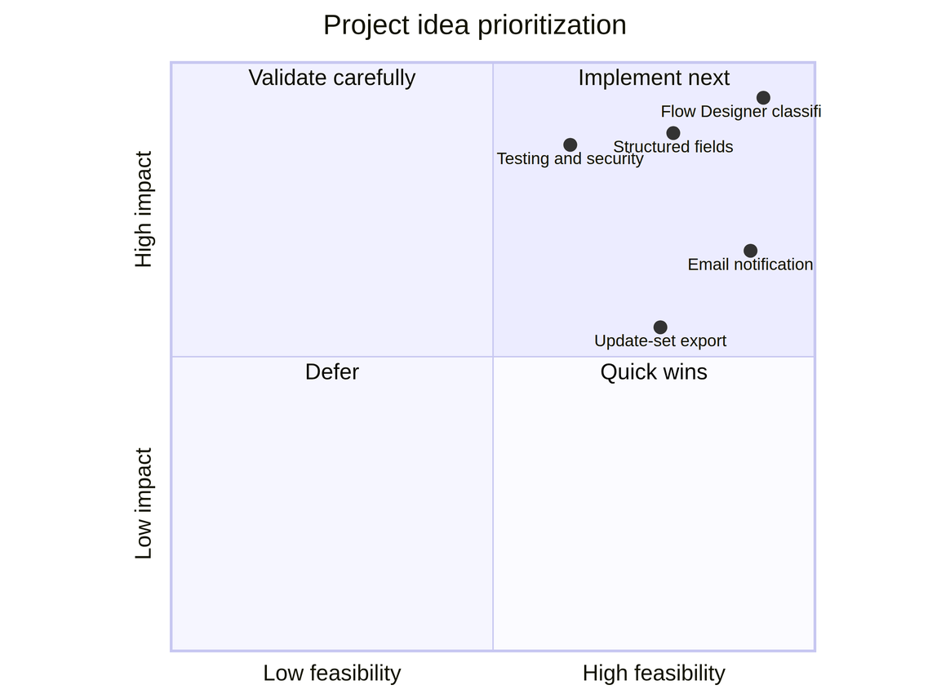

Step 2: Generate and group automation ideas
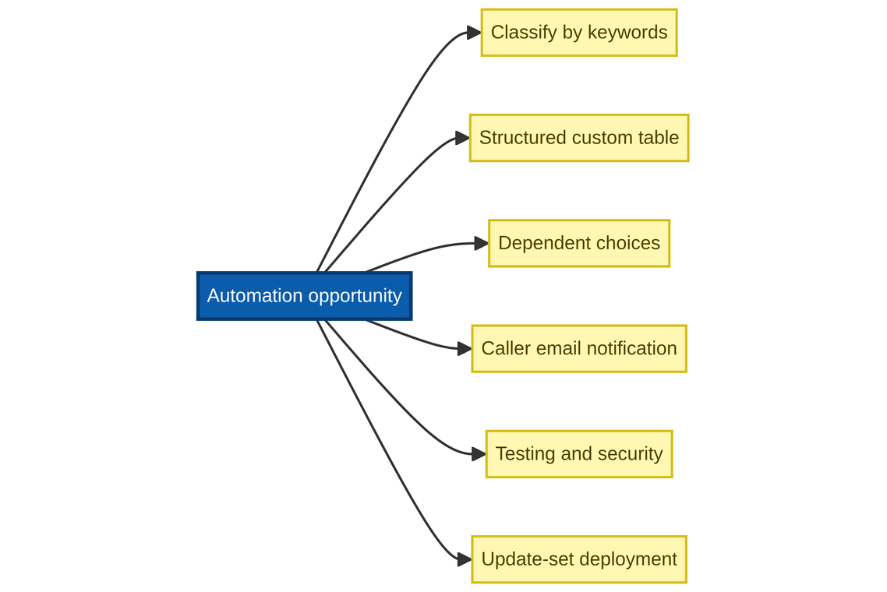

Step 3: Prioritize ideas by impact and feasibility
